1. 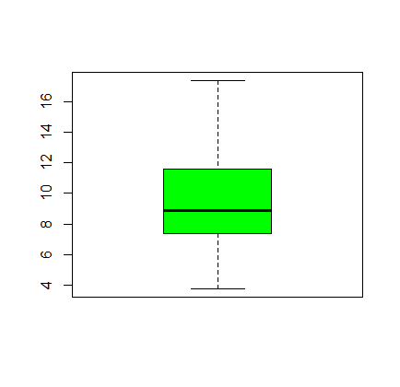From the Boxplot to the right describe the “shape” of the distribution.

**Right-Skewed, since the tail is longer at the top**

1. What requirement is there in order to use the 68-95-99.7 Rule for a distribution?

**The distribution needs to be normal.**

1. Would it be appropriate to use the 68-95-97 Rule with the Distribution represented by the boxplot above?

**The 68-95-97 Rule with the Distribution represented by the boxplot above would not be appropriate since the data is right skewed.**

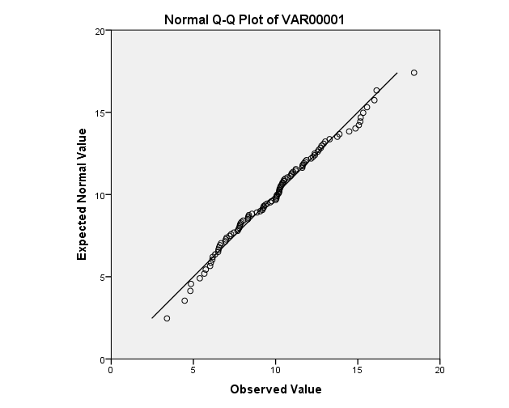

1. Is the QQ plot to the right approximately normal? Why?

**Yes, Since most of the points are at or near the diagonal line, plus the points are not trailing off from the diagonal line.**

1. Would the distribution of sample means (sampling distribution) corresponding to this QQ plot be normally distributed? Why?

**The distribution of means would be normal since the data appear to come from a population that is normal.**

1. What are the two ways to ensure a normally distributed distribution of sample means (sampling distribution)?
2. **The sample size is large (Central Limit Theorem)**
3. **The original population has a distribution that is normal.**
4. From previous semesters the time to take the Unit 1 Exam for 221B has been approximately normally distributed with a population mean of 48 minutes, and population standard deviation of 16 minutes.
   1. What is the Probability that it will take you longer than 1 hour (60 minutes) to take the Unit 1 Exam.

**Z=0.75**

**Probability= 0.227**

* 1. What do the results from “part-a” mean in context? Specifically what are the risks of waiting until the last hour to take the test?

**It means that there is a decent chance (about 23%) that the test will take longer than 60 minutes.**

* 1. Now consider that a sample of 25 students was taken and the sample mean was recorded. What is the probability that the sample mean will be longer than 1 hour?

**Z=3.75**

**Probability= almost zero (0.000 – rounded three decimal places)**

* 1. Will the distribution of sample means be approximately normal? Why?

**Yes, since test times from the population are approximately normal.**